Bringing Forward God’s Tithes and Our Gifts

*Doxology **# 95 Praise God from whom all blessings flow; praise him, all Creatures here below;** **praise him above, ye heavenly host; praise Father, Son, and Holy Ghost. Amen.**

*Prayer of Thanksgiving

Sharing of Joys and Concerns

The Lord’s Prayer

**Our Father, who art in heaven, hallowed be thy name. Thy kingdom come, Thy will be done on earth as it is in heaven. Give us this day our daily bread and forgive us our trespasses, as we forgive those who trespass against us. And lead us not into temptation, but deliver us from evil. For thine is the kingdom, and the power, and the glory, forever. Amen.**

*Singing Our Faith **# 529** *“How Firm a Foundation”*

*Blessing and Dismissal

*Postlude

**Scatter to Serve God & Neighbor**

*Welcome to all! We gather to praise God for the innumerable blessings given to us and to grow deeper in the Spirit. Joyfully, let us lift our hearts to God.*



*DIRECTORY OF CHESTNUT HILL UNITED METHODIST CHURCH*

|  |  |  |  |
| --- | --- | --- | --- |
| Bishop Sue Haupert-Johnson | | Richmond Area Resident Bishop | |
| Rev. Dr. Sarah Calvert | | Mountain View District Superintendent | |
| Adam White | | Minister | |
| Erin Long | | Associate Minister | |
| Monica Campbell | | Administrative Assistant | |
| Heather Wilson | | Director of Music Ministry | |
| Judy Martin | | Bookkeeper | |
| Judy Robertson  Elizabeth Nichols | | Lay Leader  Missionary in Henry County | |



*C* *hestnut Hill*

***United Methodist Church***



*Making disciples of Jesus Christ   
for the transformation of the world.*

*You are welcome at Chestnut Hill UMC.*

4660 Fort Avenue ~ Lynchburg, Virginia 24502

Church: 434-239-8423

Minister’s Cell: 434-944-7723, Minister’s Email: awhite@ves.org

Associate Minister’s Cell: 1-502-489-0200

Associate Minister’s Email: healingsolutions12@gmail.com

Email: [chestnuthillumc@comcast.net](mailto:chestnuthillumc@comcast.net)

On the Web at chestnuthillumc.net

Find us on Facebook: Chestnut Hill United Methodist Church

**

*Chestnut Hill United Methodist Church*

10:30 a.m. ~ July 21, 2024 ~ Ninth Sunday after Pentecost

Our ministry vision for the Virginia Annual Conference is ***“to be disciples of Jesus Christ who are lifelong learners, who influence others to serve.”***

***Welcome! Join us in worshiping God!***

Prelude *“It is Well with My Soul”*  H. Lemmel

Welcome and Ministry Announcements

*Welcome in the name of Christ our Lord. Please register your attendance, printing your name, address, phone, and email, on the attendance pad provided on your pew. Thank you for silencing cell phones as we gather to worship God.*

Invocation

*Greeting

Eternal God, Uncreated Creator, Life-giver and Sustainer, You created us in your image. From the beginning, you made us to show the world who you are and what you are like.

**To find our identity in you.**

From the beginning, you blessed so that we would be blessings. ([Genesis 12:2](https://www.biblegateway.com/passage/?search=Genesis%2012&version=NIV))

**To find our identity in you.**

And yet we stray.

**Prone to wander, Lord we feel it.**

When Jesus went out to John to be baptized ([Matthew 3:13-17](https://www.biblegateway.com/passage/?search=Matthew%203%3A13-17&version=NIV)),

he did not do so out of repentance.

**But to identify with his people**. **God dwelt among us**.

He was in the world, and though the world was made through him, the world did not recognize him (John 1:10).

But, you have redeemed a people for yourself.

**You have blessed us to be a blessing.**

Through the work of You the Holy Spirit, we are united to You the Son so that what is true of Jesus is true of us.

**We find our identity in Jesus.**

When Jesus went out to John to be baptized, the skies parted, the Spirit descended like a dove, and the Father’s voice said:

**You are my child and I am well-pleased**.

Lord, help us to believe this about ourselves.

**We are your children and you are well-pleased with us. Even when we are not.**

*Singing Our Faith **# 73** (verses 1, 2, 4 & 5) *“O Worship the King”*

Opening Prayer

**Loving God, as this day opens into new and untold possibility, purge me of my compulsive need to carry useless baggage-physically, mentally or emotionally. Teach me to walk simply with you as I trust in your abundant provision. Amen**

Special Music *“Heaven Came Down”*  J. Peterson

Greeting Friends and Neighbors

Prayer for Illumination Ann Robbins

**Almighty God, in you are hidden all the treasures of wisdom and knowledge. Open our eyes that we may see the wonders of your word; and give us grace that we may clearly understand and freely choose the way of our wisdom; through Christ our Lord. Amen**

Scripture Lessons Ann Robbins

Judges 6:11-12 and Ephesians 1:1-6

The Word of God for the people of God.

**Thanks be to God.**

Singing Our Faith **# 362** *“Nothing but the Blood”*

The Good News ***“Who God says you are”***

***\*\*Calendar \*\****

|  |  |  |
| --- | --- | --- |
| Monday, 7/22 | 8:30 a.m. | *Camp Meadowlark* |
|  |  |  |
| Tuesday, 7/23 | 8:30 a.m. | *Camp Meadowlark* |
|  |  |  |
| Wednesday, 7/24 | 8:30 a.m. | *Camp Meadowlark* |
|  | 6:30 p.m. | *Camp Meadowlark Family Night* |
|  |  |  |
| Thursday, 7/25 | 8:30 a.m. | *Camp Meadowlark* |
|  |  |  |
| Friday, 7/26 | 8:30 a.m. | *Camp Meadowlark* |

In Memoriam

*Alice Jacquline “Jackie” Vest*

October 26, 1937 – July 12, 2024

*Chestnut Hill United Methodist Church extends Christian love and sympathy* to the family of *Jackie Vest*  and especially to her son-in-law, Ryan Balderson and grandson, Ryan. Jackie was preceded in death by her daughter, Tammy Balderson.

**For the Grocery Cart: July**

Toothpaste, toothbrushes, deodorant, soap, body wash, shampoo, laundry detergent, and dish soap. Place donations in the grocery cart, located in the Commons.

**Cards for Homebound Members**

Please take a moment to sign the cards for our homebound members/friends that Erin has placed in the Commons.

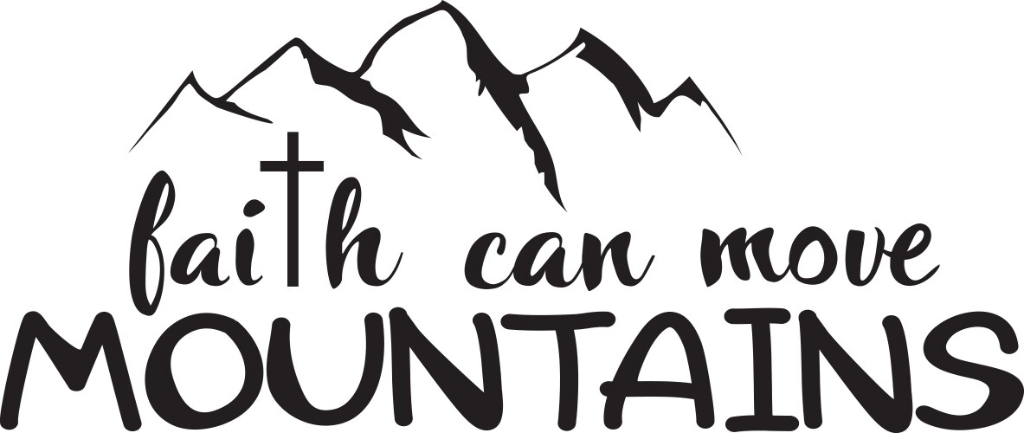

***\*\*Calendar \*\****

|  |  |  |
| --- | --- | --- |
| Monday, 7/22 | 8:30 a.m. | *Camp Meadowlark* |
|  |  |  |
| Tuesday, 7/23 | 8:30 a.m. | *Camp Meadowlark* |
|  |  |  |
| Wednesday, 7/24 | 8:30 a.m. | *Camp Meadowlark* |
|  | 6:30 p.m. | *Camp Meadowlark Family Night* |
|  |  |  |
| Thursday, 7/25 | 8:30 a.m. | *Camp Meadowlark* |
|  |  |  |
| Friday, 7/26 | 8:30 a.m. | *Camp Meadowlark* |

In Memoriam

*Alice Jacquline “Jackie” Vest*

October 26, 1937 – July 12, 2024

*Chestnut Hill United Methodist Church extends Christian love and sympathy* to the family of *Jackie Vest*  and especially to her son-in-law, Ryan Balderson and grandson, Ryan. Jackie was preceded in death by her daughter, Tammy Balderson.

**For the Grocery Cart: July**

Toothpaste, toothbrushes, deodorant, soap, body wash, shampoo, laundry detergent, and dish soap. Place donations in the grocery cart, located in the Commons.

**Cards for Homebound Members**

Please take a moment to sign the cards for our homebound members/friends that Erin has placed in the Commons.

